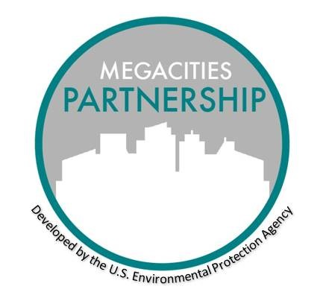

MEGACITIES PARTNERSHIP

Template Instructions

May 2021

1. Introduction to the Megacities Partnership

The Megacities Partnership aims to build technical capacity and develop air quality management policies in cities around the world. The Partnership typically spans an 18-24 month period where Megacity Partner organizations and host agencies collaborate to assess gaps and needs, characterize baseline air quality and its impacts, and create a path forward for developing an air quality management process in the city.

During the 2015 – 2020 period, the United States Environmental Protection Agency (USEPA) conducted four Megacities Partnerships: Accra, Ghana; Santiago, Chile; Addis Ababa, Ethiopia, and Lima, Peru. Each Partnership broadly analyzed the current air pollution management and data collection systems in the area, before narrowing the scope to achieve a city-specific, evidence-based final product. Accra and Addis Ababa Megacities Partnerships drafted or are drafting Air Quality Management Plans (AQMP), while the Santiago Partnership performed a retrospective benefits analysis.

2. Template Motivations and Description

Each Partnership is inherently unique to the city – the local policy, scientific, and cultural context, the data available, and goals vary in each Megacity and drive the direction of the Partnership. Nonetheless, there are some basic frameworks (templates) for certain steps in the process, (e.g., information collection, needs assessment, and capacity building) that are relevant to all Megacities and inform the progression of the project. These templates provide meaningful structure to the project, while still maintaining flexibility to meet each Megacity’s needs.

The project templates are generalized documents that can be used throughout a Megacities Partnership or any air quality management planning process to facilitate the creation of concrete deliverables. While **Figure 1** below shows an example of a typical 18-month timeline, Partnerships can be expanded or modified based on an individual city’s context and needs. Throughout the template documents, the primary government agency collaborating under the Partnership is referred to as the “city host agency,” and the partnering organization providing assistance to the city is called the “Megacity Partner organization”. These templates guide the city host agency and the Megacity Partner organization through the main milestones of the Megacities Partnership.

The templates provide basic suggestions of content, research, and analyses that are effective in characterizing air pollution, assessing the gaps and limitations of current capacity, and understanding areas with the highest potential for action. The templates can be used directly or adapted to the specific city needs as the project manager sees fit. Aspects of the deliverables may be more relevant in certain contexts and less relevant in others, so it is left up to the discretion of the project manager to organize, change, or remove deliverables to ensure applicability to the city host agency. The date included shows the publication date of the template materials.

**Figure 1** is an example of a Megacities Partnership project framework built around selected templates. It also includes a general timeline for when deliverables described by these templates are likely to be completed within the estimated 18-month project period. This does not reflect the full suite of available templates which are described more fully below. There are templates included in the Megacities Partnership Template collection to assist with each of these aspects of air quality management planning.

Figure 1. Example Megacities Partnership Templates and Timeline

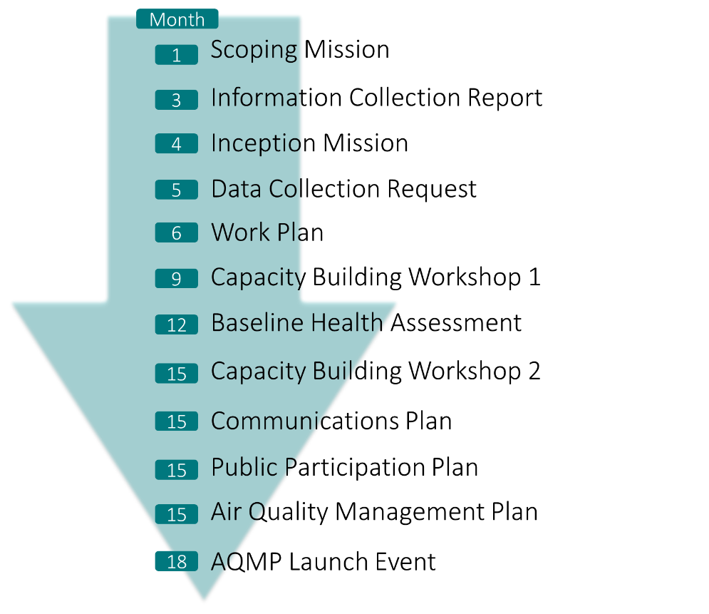

3. Detailed Template Descriptions

**Scoping and Inception Template:** This guide includes a variety of questions for local actors, spanning all sectors involved in air quality management. These questions can be used to start a discussion with a city host agency and other potential Megacity Partners about their current capacity, investment, and interest in collaborating under the Partnership. The objective of the Scoping and Inception phases of a partnership is to introduce a Megacity Partner organization to the local political context, gain insight on the will of the city government, including the city host agency, to commit resources towards air quality management, and understand if the timing is right to commence the Partnership. Additional questions may be necessary, depending on the city context and objectives of the Megacity Partner organization.

The Inception phase can be combined with the scoping phase and together these phases may involve one or more visits to a host megacity under the Partnership once the Partnership is solidified. A workshop is usually held shortly after or as part of the Inception phase. It gathers relevant stakeholders and main local actors carrying out the Partnership together with in-country staff. The workshop’s objectives could include introducing the Partnership, initiating relationships with local partners, and presenting the fundamentals of air quality management, analysis, and communication. Topics for any capacity building workshop are suggested in the Capacity Building Template. As part of an inception phase, an advisory committee can be established (see Additional Resources on Megacities Webpage).

**Information Collection Report (ICR) Template:** This template provides structure for a literature review and report to contextualize air quality management throughout the city and country. The ICR summarizes peer-reviewed literature, laws, and government plans and reports surrounding air quality monitoring, policy, enforcement /compliance, and future, known investments in air quality. The report should detail the air quality monitoring network, main emission sources, governmental capacity, and health/ economic burden of air pollution within the city, to the extent these are known. The report concludes with an assessment of strengths, limitations, and areas of further research.

The key objectives of the ICR include identification of key players, including but not limited to municipal agencies, federal agencies, academic institutions, and non-profit organizations, involved in air quality management, air quality monitoring, air quality analyses (e.g. health burden, source apportionment) within the city and/or country for air quality management, and analytical and technical capabilities related to air quality monitoring and analysis. The Megacity Partner organization will share a draft ICR with the city host agency to edit and confirm the findings. The acceptance of the ICR by the collaborating city will confirm a common narrative of air quality policy and management, to which all stakeholders agree.

**Data Collection Requests Templates:** The Data Collection Requests (DCRs) list information and data sources, both quantitative datasets and reports, that can directly inform relevant analysis and/or will be used throughout the Partnership. The Data Requests should be sent to relevant agencies and contacts, identified through the Scoping and Inception Phases and ICR research. Although it is unlikely that city and national target agencies will have all of the data listed in the request readily available, it is important to understand the data availability and open communication channels with the managing agencies of relevant data collection.

Two typical types of DCRs are for **Air Quality Emissions** and **Human Health Services**, and templates are available for both. These types of datasets make up the foundation to the health burden analyses and air quality capacity assessment. It is essential that both the local actors and Megacity Partner organization understand the extent of available data, data management systems, and limitations of the data collected. Partners can use this information to fill in the identified gaps with globally available datasets (see Additional Resources on the Megacities Webpage) and to refine these data as the project progresses.

Collaborating partners should maintain an up-to-date data catalog, which includes the data received, the agency responsible for maintaining the data, points of contact, and any notes, comments, or questions associated with the data. This data catalog should be updated regularly as new data becomes available and to keep track of the datasets used in specific analyses.

**Inception Report and Workplan Template:** The Inception Report and Workplan outlines the organizational structure and relationships between stakeholders, presents the results of the data collection process and major data gaps, and creates a well-defined timeline of agreed upon tasks and responsibilities. The workplan guides key next steps and actions throughout the Partnership to ensure progress and accountability. Where previous steps and deliverables focus on characterizing air pollution and contextualizing air quality management, the Inception Report and Workplan lay out project specific management, organization, and concrete actions to reaching the ultimate goal decided by the stakeholders. These deliverables require focused back-and-forth communication between the Megacity and partners to determine appropriate options for collaboration and project details to move forward.

The template includes generic language that can be included within the document, example schematics, as well as instructions for city-specific content indicated in italic font.

**Capacity Building Workshops Agenda Template:** The Capacity Building Workshop(s) gathers together mid-level technical staff and begins the training necessary to carry out the items described in the workplan. Previous Megacities Partnerships have focused on benefits analysis, preparation for drafting of the air quality management plan, and laboratory analysis techniques. The specific objectives, topics, and trainings of this workshop are city-specific and should align with local actors’ needs. Additional capacity building workshops can be conducted, if necessary, to continue developing the skills introduced in Workshop 1. Additional topics have included the drafting of the AQMP and conducting benefits analyses for alternative policy scenarios.

**BenMAP Overview and Organizer Template:** The BenMAP Template is a helpful resource for teams interested in or planning to use BenMAP-CE—an air quality benefits analysis software—to quantify health impacts from air pollution within the Megacity. These documents introduce BenMAP-CE, the data necessary to run BenMAP-CE, resources to get started, and example analyses previous Megacity Partners performed using the software. BenMAP-CE’s installer and resources can be found at: <https://www.epa.gov/benmap>

**Communications Plan Template:** The Communications Plan lays out the specific goals and actions for communicating the findings of the Partnership to the public, policy/decision makers, and international donors. Communicating to different audiences can be complex; it is essential to curate and develop specific messaging to resonate with different potential audiences. In addition, developing a communication plan can be an important step in identifying potential supporters and planning for a range of public facing activities when the AQMP is final.

Previously, the template has been filled out during a working session at a Capacity Building Workshop, while relevant parties are present, and is refined afterwards. Coordination and agreement on responsibilities is often easier in person, with full representation of the stakeholders involved.

**Public Involvement Plan Template:** The Public Involvement Plan development coincides with the goals and objectives of the communication planning. The public must be actively aware of the current air quality situation, Partnership findings, and policy implications of the Partnership’s outcomes. As the public will ultimately be affected by and participating in the planned actions, a plan to receive meaningful public input and feedback should be discussed frequently throughout the Partnership. The template provides a framework for organizing public involvement internally and targeting relevant audiences.

Previously, the template has been filled out during a working session at a Capacity Building Workshop, while relevant parties are present, and is refined afterwards. Coordination and agreement on responsibilities is often easier in person, with full representation of the stakeholders involved.

**AQMP Draft Template:** A completed AQMP Draft has been a primary output for previous Megacities Partnerships (e.g. Accra, Ghana; Addis Ababa, Ethiopia). The AQMP is a comprehensive document describing the motivations for air quality management, qualitative and quantitative findings on the impacts of air pollution on the megacity, and most importantly, targeted actions and a path forward for mitigating sources of air pollution. In some cases, the AQMP has also serves as a tangible milestone and blueprint for action to attract additional donor support for implementing the AQMP.

The AQMP incorporates the findings of all stages of the partnership and is primarily drafted by the city host agency, with guidance from the Megacity Partner organization. Previously, the template has been initially filled out at a Capacity Building Workshop, while relevant parties are present, and is refined afterwards as analyses are completed and updated. The document typically goes through many drafts before being formally accepted by the city host agency and the city government.

The final document will be available to the public, and subject to the conditions of the public involvement and communication plans described above. The final AQMP can serve as an important launching point for discussions with the donor community, which may be looking for concrete funding opportunities to improve air quality.

**AQMP Launch Event Agenda Template:** The AQMP Launch Event gathers a wider audience, from local institutions affected by the plan, general public, and international donors, to present the main findings and policy implications of the AQMP. The launch event will introduce the AQMP to implementing agencies and will generate positive press for the Megacity’s efforts thus far. Suggested sessions for the event are included in the agenda template.

**Implementation Project Template:**  After an AQMP is launched, the city and stakeholders should try to take action to improve air quality, ideally by implementing a project that supports one of the AQMP objectives and has been identified by stakeholders as an important area for action. This template provides a framework for considering implementation objectives as well as considerations for selecting, planning for, and implementing an achievable project.