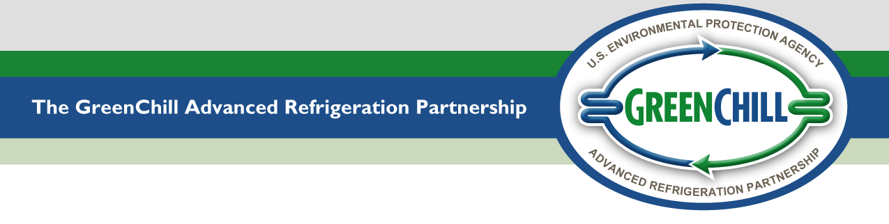

~Confidential Business Information~
Re-certification of Food Retail Stores
GreenChill’s Store Certification is valid for one year. At the end of your store’s certification period, you may apply to have your store re-certified for an additional year. If your store is applying to re-qualify for GreenChill Platinum-, Gold-, or Silver-Level Store Certification, please answer the following questions about the store seeking re-certification.
- STORE NAME (as you would like it to appear on the award certificate):
STORE #: |  |  | STREET ADDRESS:
CITY: |  |  |  |  | State: |  | Zip:

 | Refrigeration System Type and Manufacturer (check one box for the medium temperature system and list the manufacture of that system, and check one box for the low temperature system and list the manufacturer of that system)
 | System Type | Medium Temperature Sytem |  | Low Temperature System
 | System Type | Type | Manufacturer | Type | Manufacturer
 | Centralized Direct Expansion Parallel Rack
 | Distributed Direct Expansion
 | Glycol Secondary Loop
 | CO₂ Secondary Loop
 | CO₂ Cascade
 | Transcritical CO₂
 | Other (please specify):
 | Refrigerant TYpe and Charge Size (complete the table below)

EQUIPMENT TYPE | Remote Commercial Refrigeration System |  | Self-Contained Equipment* | HVAC Equipment**
EQUIPMENT TYPE | Medium Temperature | Low Temperature | Self-Contained Equipment* | HVAC Equipment**
Primary Refrigerant Type
Primary Refrigerant Charge (lbs)
Secondary Refrigerant Type
Secondary Refrigerant Charge (lbs)
*Including soda machines, vendor supplied coolers, ice machines, refrigerators in deli areas, etc.
**Including “personal” AC in staff offices

- Change in total remote commercial refrigeration load (MBTUs/HOUR) since the store’s last
GreenChill certification? | NO YES
If YES, record the store’s total remote commercial refrigeration load (MBTUs/hour) below and attach a copy of the store’s current refrigeration system legend (schedule) that lists the BTU output of all remote commercial refrigeration equipment.
TOTAL REMOTE COMMERCIAL REFRIGERATION LOAD (MBTUS/HOUR):
DO NOT include the store’s HVAC system (split systems or self contained), self-contained refrigeration equipment, sub-cooling, heat of rejection, or pump heat.
- Amount of Refrigerant (LBS) emitted over the last 12 months:
DO NOT include emissions from HVAC equipment or self-contained refrigeration equipment.
SUPPORTING DOCUMENTATION FOR ANNUAL EMISSIONS: Documentation may include an emissions report generated from your store’s leak tracking software, a refrigeration system status report, or a signed letter from your store’s servicing/maintenance contractor confirming the quantity of refrigerant added to the system over the past year. If there have been zero leaks, a signed letter by the person/contractor responsible for tracking leaks is also acceptable.
- Signature/Certification by Authorized Company Representative
Please have an authorized representative of the store seeking certification sign this application to attest that all information contained is true and correct.
Name: |  |  |  | Title:
Telephone: |  |  |  | Email:
Signature: |  |  |  | Date:
- Contact Information
Please provide contact information for a technical contact regarding the store certification application.
Name: |  |  |  | Title:
Street Address:
City: |  |  |  | State: |  |  | Zip:
Telephone: |  |  |  | Email:

For assistance on completing the form, please refer to the GreenChill Store Certification Program Guidance. Please direct any questions and send completed forms and attachments to GreenChill@epa.gov.

GreenChill reserves the right to deny store certification based on a company's Clean Air Act Title 6 enforcement issues
Note: When referring to any EPA award, please include the year in which the award was received.

All information provided will be treated as confidential business information (CBI), as stipulated under Clean Air Act provisions, and will not be divulged either to other Partners or publicly.
If you do not receive an email confirming receipt of your application within two business days, please notify EPA.

